Enterprise Network Design & Implementation Project
Network Documentation
VLANs | Trunking | Router-on-a-Stick | OSPF | SSH

Prepared by: Mohamed Elsayad
Trainer: Eng. Saher Waleed
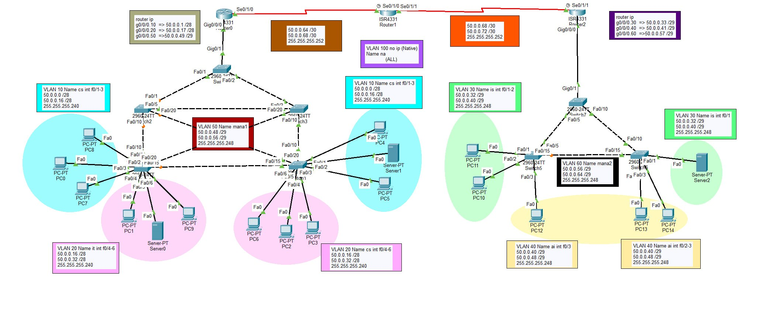

Outline
1. Subnetting Plan
2. IP Address Assignment — End Devices
3. VLAN Design & Creation
4. Access & Trunk Port Configuration
5. Management (SVI) Configuration
6. Inter-VLAN Routing — Router-on-a-Stick
7. Router IP Addressing (WAN Links)
8. OSPF Routing Configuration
9. Remote Access — SSH, Telnet & Password Encryption
10. Troubleshooting & Final Verification

Project Introduction
This document presents a full walkthrough of an enterprise network project implemented in Cisco Packet Tracer, starting from subnetting the address space, through VLAN creation, access/trunk configuration, management SVIs, Router-on-a-Stick inter-VLAN routing, OSPF dynamic routing, and securing devices with SSH/Telnet and password encryption, ending with troubleshooting and connectivity verification.
The network is built around the address block 50.0.0.0/24, divided using VLSM. It is split into a Left segment (Router R1 with switches S1–S5) and a Right segment (Router R2 with switches S6–S8), connected through a transit router (R3) over two point-to-point serial WAN links. VLAN 100 (na) is used as the Native VLAN on every trunk link across the whole topology.


1. Subnetting Plan
The 50.0.0.0/24 block was divided using VLSM into 6 LAN subnets (4 data VLANs + 2 management VLANs) and 2 WAN point-to-point links, sized according to the number of hosts on each segment. VLAN 100 is Native-only and carries no IP subnet.
# | Network / Link | Network Address | Subnet Mask | CIDR | Usable Range
1 | VLAN 10 – Data (Left) – cs | 50.0.0.0 | 255.255.255.240 | /28 | .1 – .14
2 | VLAN 20 – Data (Left) – it | 50.0.0.16 | 255.255.255.240 | /28 | .17 – .30
3 | VLAN 30 – Data (Right) – is | 50.0.0.32 | 255.255.255.248 | /29 | .33 – .38
4 | VLAN 40 – Data (Right) – ai | 50.0.0.40 | 255.255.255.248 | /29 | .41 – .46
5 | VLAN 50 – Mgmt (Left) – mana1 | 50.0.0.48 | 255.255.255.248 | /29 | .49 – .54
6 | VLAN 60 – Mgmt (Right) – mana2 | 50.0.0.56 | 255.255.255.248 | /29 | .57 – .62
7 | WAN – R1 ↔ R3 | 50.0.0.64 | 255.255.255.252 | /30 | .65 – .66
8 | WAN – R3 ↔ R2 | 50.0.0.68 | 255.255.255.252 | /30 | .69 – .70
VLAN 90/100 (Native) exists on every trunk link across the network without an IP subnet — it only carries untagged traffic and is not assigned to any real device, as a security best practice.

2. IP Address Assignment — End Devices
Static IP addresses were assigned to all end devices and servers from their VLAN's address block (see Section 1), with each device using the default gateway of its VLAN — the router sub-interface serving that VLAN.
Device(s) | VLAN | Address Block | Default Gateway
PC8, PC0, PC7, PC4, Server1, PC5 | 10 (cs) | 50.0.0.0/28 | 50.0.0.1
PC1, Server0, PC9, PC6, PC2, PC3 | 20 (it) | 50.0.0.16/28 | 50.0.0.17
PC11, PC10, Server2 | 30 (is) | 50.0.0.32/29 | 50.0.0.33
PC12, PC13, PC14 | 40 (ai) | 50.0.0.40/29 | 50.0.0.41
Connectivity for all end devices was verified through ping testing — see the final results in the Troubleshooting section.

3. VLAN Design & Creation
VLANs were created on all switches with the numbers and names agreed on in the design:
VLAN ID | Name | Side | Purpose
10 | cs | Left | PC8, PC0, PC7, PC4, Server1, PC5
20 | it | Left | PC1, Server0, PC9, PC6, PC2, PC3
30 | is | Right | PC11, PC10, Server2
40 | ai | Right | PC12, PC13, PC14
50 | mana1 | Left | Management SVI for left-side switches
60 | mana2 | Right | Management SVI for right-side switches
100 | na | Both | Native VLAN on every trunk link — no hosts
Example — creating the VLANs on a right-side switch (S6):
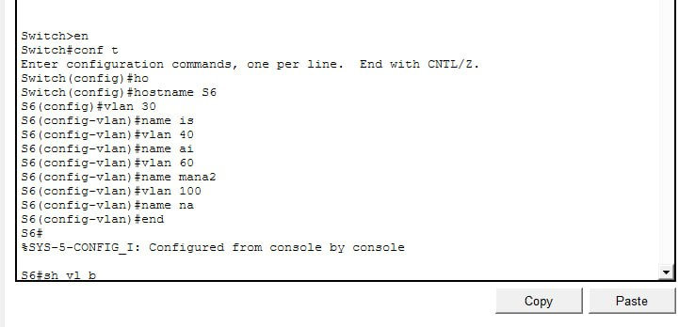
The same VLANs (30, 40, 60, 100) were created identically on switches S7 and S8, and VLANs (10, 20, 50, 100) on switches S1 through S5, keeping the VLAN database consistent across the whole topology.

4. Access & Trunk Port Configuration
Access ports connect end devices and carry a single VLAN untagged; trunk ports interconnect switches (and switches to routers) and carry multiple VLANs tagged with 802.1Q, using VLAN 100 as the Native VLAN.
Access Port Configuration (example — S6)
Ports Fa0/1–2 were set to VLAN 30 and port Fa0/3 to VLAN 40 using interface ranges, then verified with show vlan brief:
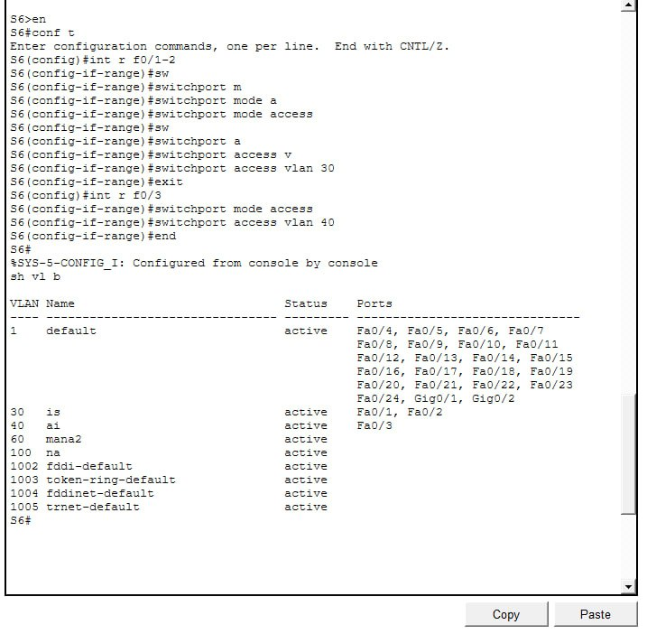
Trunk Port Configuration & Native VLAN Correction
While bringing trunk links up between the switches, a Native VLAN Mismatch was detected because one side of a link still used the default Native VLAN (1) instead of VLAN 100. The trunk was reconfigured consistently on both ends (switchport trunk native vlan 100 and switchport trunk allowed vlan 10,20,50,100), and the inconsistency was automatically cleared, as shown by the Unblocking messages below:
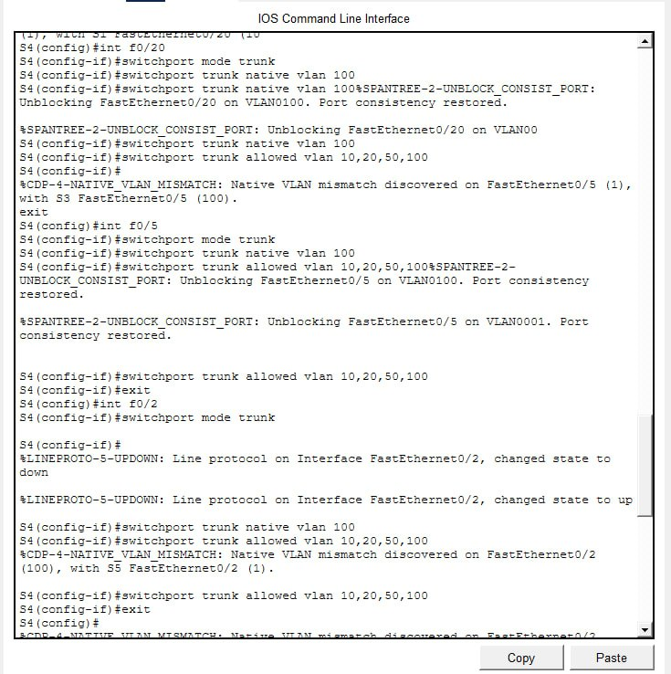

5. Management (SVI) Configuration
A dedicated management VLAN was assigned to each half of the network: VLAN 50 (mana1) for the left side and VLAN 60 (mana2) for the right side. An SVI (Switch Virtual Interface) was created on one switch in each half, given an IP address from the management range, activated with no shutdown, and finally assigned a default gateway pointing to the corresponding router sub-interface.
Switch | VLAN | IP Address | Subnet Mask | Default Gateway
S5 (Left) | 50 – mana1 | 50.0.0.54 | 255.255.255.248 | 50.0.0.49
S8 (Right) | 60 – mana2 | 50.0.0.60 | 255.255.255.248 | 50.0.0.57
Configuration and connectivity test on S8 (VLAN 60 SVI):
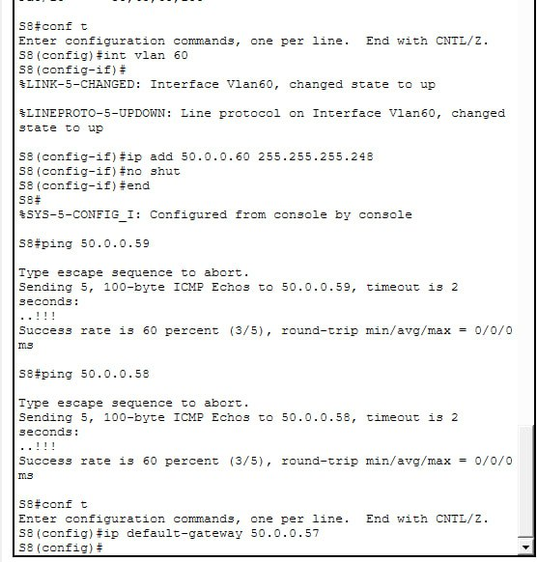

6. Inter-VLAN Routing — Router-on-a-Stick
Router-on-a-Stick was configured on R1 and R2: the physical port g0/0/0 was enabled on each router, then a sub-interface was created for every VLAN, using 802.1Q encapsulation with the matching VLAN ID and an IP address acting as that VLAN's default gateway. Router R3 has no VLAN sub-interfaces — its only role is OSPF transit between R1 and R2 over the serial links.
R2 configuration — sub-interfaces for VLANs 30, 40, and 60:
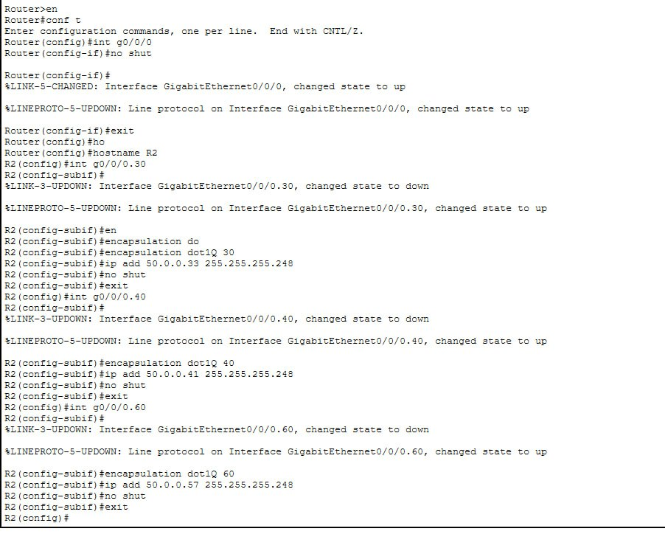
R1 was configured the same way for VLANs 10, 20, and 50 (g0/0/0.10, g0/0/0.20, g0/0/0.50).

7. Router IP Addressing (WAN Links)
In addition to the sub-interface addresses, the serial interfaces linking R1, R3 (transit), and R2 were configured with the WAN link addresses so OSPF could form adjacencies across the whole topology.
Router | Interface | IP Address | Prefix | Connects To
R1 | GigabitEthernet0/0/0.10 | 50.0.0.1 | /28 | VLAN 10
R1 | GigabitEthernet0/0/0.20 | 50.0.0.17 | /28 | VLAN 20
R1 | GigabitEthernet0/0/0.50 | 50.0.0.49 | /29 | VLAN 50
R1 | Serial0/1/0 | 50.0.0.65 | /30 | R3
R3 | Serial0/1/0 | 50.0.0.66 | /30 | R1
R3 | Serial0/1/1 | 50.0.0.69 | /30 | R2
R2 | Serial0/1/1 | 50.0.0.70 | /30 | R3
R2 | GigabitEthernet0/0/0.30 | 50.0.0.33 | /29 | VLAN 30
R2 | GigabitEthernet0/0/0.40 | 50.0.0.41 | /29 | VLAN 40
R2 | GigabitEthernet0/0/0.60 | 50.0.0.57 | /29 | VLAN 60

8. OSPF Routing Configuration
Single-area OSPF (Process ID 10, Area 0) was enabled on R1, R2, and R3, with each router advertising the networks directly connected to it. R3 acts purely as an OSPF transit router between the two halves of the network.
- R1: networks 50.0.0.0/28, 50.0.0.16/28, 50.0.0.48/29, 50.0.0.64/30
- R2: networks 50.0.0.32/29, 50.0.0.40/29, 50.0.0.56/29, 50.0.0.68/30
- R3: networks 50.0.0.64/30, 50.0.0.68/30
After configuration, all three routers reached FULL adjacency, confirmed by the %OSPF-5-ADJCHG messages below:
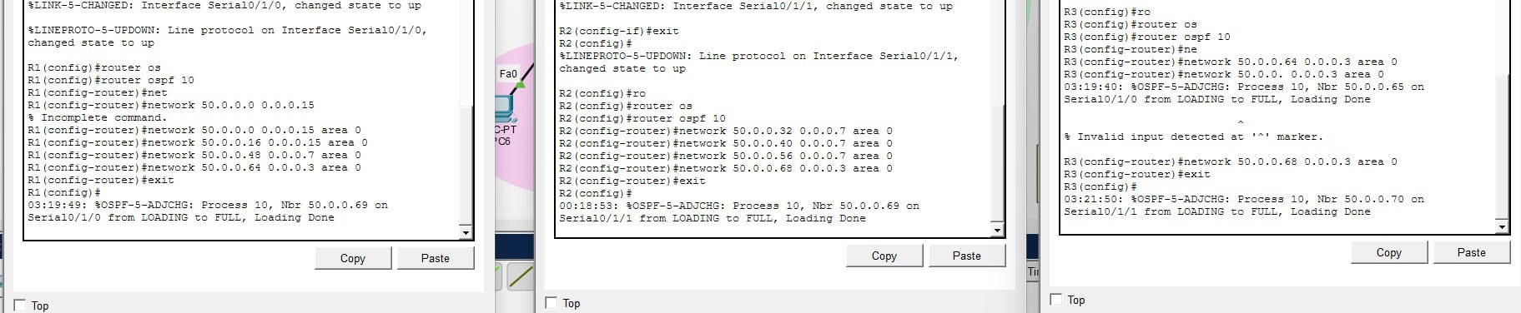

9. Remote Access — SSH, Telnet & Password Encryption
To secure remote access, the following steps were carried out on every router and switch (shown here on R3):
- enable secret to encrypt the privileged-mode password, and a console password with login.
- service password-encryption to encrypt all passwords stored in the running configuration.
- ip domain name, a required step before generating SSH keys.
- crypto key generate rsa (1024-bit) to enable the SSH service.
- A local user (username / secret) created for login authentication.
- line vty 0 5 configured with login local and transport input all, allowing both Telnet and SSH.
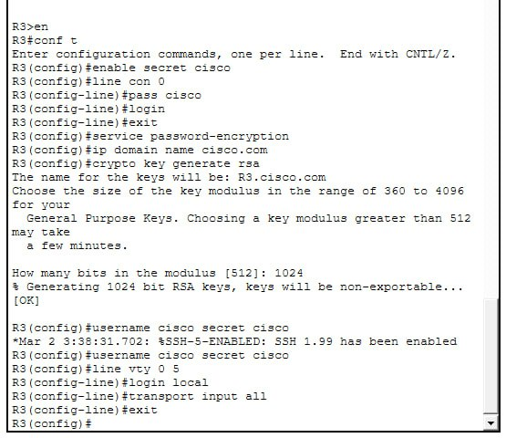
Remote SSH access was then tested successfully from a PC to several switches and routers using their management/interface IP addresses (S6, S4, R2, and R1), confirming the configuration works end-to-end:
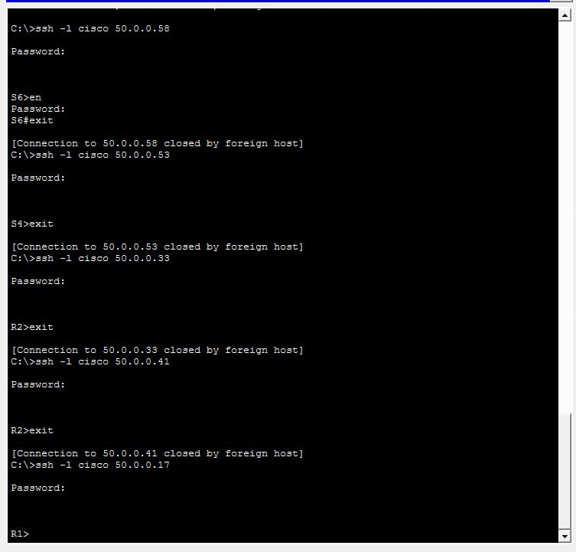

10. Troubleshooting & Final Verification
The main issue encountered during the project was a Native VLAN Mismatch (%CDP-4-NATIVE_VLAN_MISMATCH) on several trunk links, caused by one end still using the default Native VLAN (1) instead of VLAN 100. This also triggered %SPANTREE-2-BLOCK_PVID_LOCAL / RECV_PVID_ERR warnings. The fix was to explicitly set switchport trunk native vlan 100 on both ends of every trunk link, after which the ports were automatically unblocked, as shown earlier in Section 4.
Finally, after confirming that VLANs, trunking, routing, and OSPF were all correctly configured, a full ping test was carried out from an end device to several destinations across the network. All results were successful with 0% packet loss, confirming the project was completed and the network is fully operational as designed:
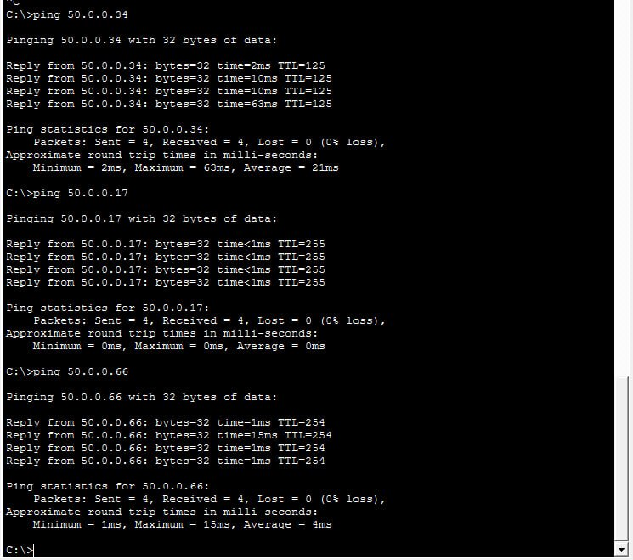

Conclusion
This project covered a complete cycle of designing and implementing an enterprise network in Cisco Packet Tracer, from theoretical planning (subnetting) to practical verification of network operation (ping and SSH testing), while applying best practices in VLAN management, routing, and security.

